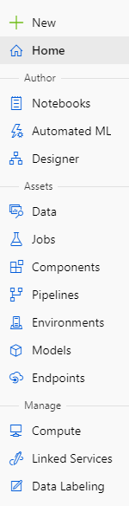

Jupyter Notebooks or other files

No-Code Auto ML

Low-Code drag and drop interface

Load or create datasets

Centralized place for monitoring ML runs

Share and reuse code with ML components

View Designer runs and publish endpoints

Manage and create ML environments

Create and organize models

Manage streaming and batch endpoints for models

Create and manage compute instances and clusters

Link synapse workspaces to Azure ML

Manage data labeling projects